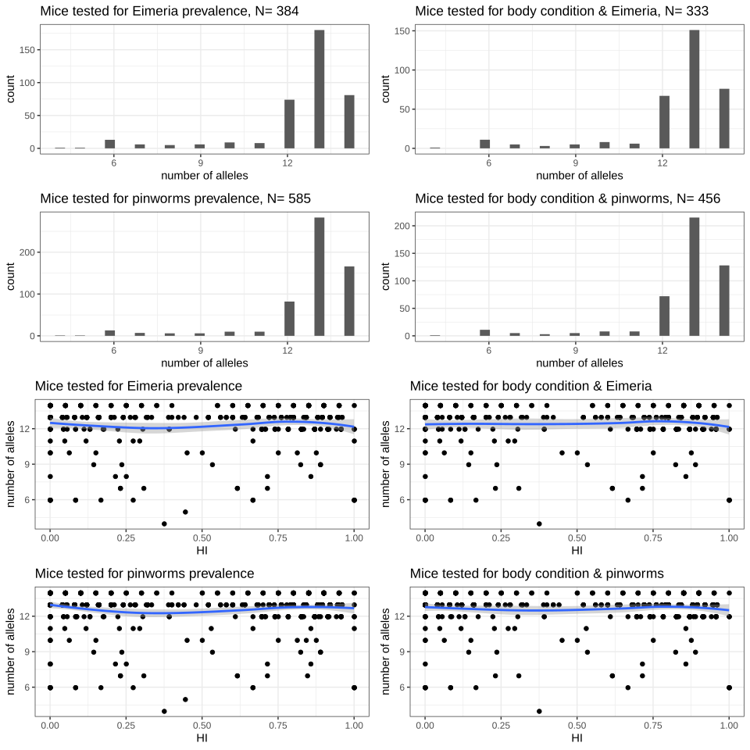

Supplementary Figure S1. Number of markers used for each analysis. Histogram of distribution, and raw data with smooth along hybrid index (HI). Blue line: smooth using method “loess”. Some mice are genotyped with less markers, nevertheless the distribution is constant along the hybrid scale.

